Nonprofit Conference Center
Center for Community Philanthropy

The Nonprofit Conference Center within the Center for Community Philanthropy (Center) is a community resource for groups to gather together with purpose. The Porter County Community Foundation (Foundation) has established the following guidelines for use of the facility:

- General Information. Permission to use the Center is not an endorsement of the user by the Foundation.

Publicity for a meeting that is not sponsored or co-sponsored by the Foundation must not be worded in a manner which states or implies Foundation sponsorship. The Foundation’s logo should not be used in promotional materials.

- Certificate of Insurance. The Foundation REQUIRES the organization provide a Certificate of Insurance for general comprehensive liability insurance with limits of at least $500,000 and naming the Porter County Community Foundation as “Additional Insured” and “Loss Payee.” Such insurance is to be provided on a primary and non-contributory basis, and the Organization waives for itself and its insurer any and all rights of subrogation against the Foundation and its affiliates. Organizations agree to indemnify and hold harmless the Foundation against all injury, loss, damage, claim or liability of any kind, whatsoever, occurring to person or property and arising out of the organization’s use of the Foundation facilities.

- Availability of Community Rooms. The community rooms are available at no charge for use by Porter County nonprofit organizations with an IRS 501(c)(3) exemption determination that exist to serve the broader public interest. Rooms are generally available for use Monday through Friday from 8:00 a.m. to 9:00 p.m. and Saturday from 8:00 a.m. to 4:00 p.m. No meetings are allowed on Sunday.

Meetings that are open to the public are allowed ONLY during the Foundation’s normal business hours (Monday through Thursday from 8:00 a.m. to 4:30 p.m. and Friday from 8:00 a.m. to 12:00 noon). In addition, all users must be able to demonstrate they operate without discrimination on the basis of age, race, religion, gender, disability or national origin. Meetings must not incur costs and/or liability to the Foundation.

Reservations must be made with the Foundation Receptionist or his/her designee.

Community rooms will not be available for the following:
- Private parties and social functions such as wedding receptions, dances, parties, etc.;
- Religious services;
- Sales solicitations;
- Activities that would subject the Center to extraordinary stress or increase the hazard of fire;
- Activities where a fee is charged for participation;
- Fundraising events such as car washes, rummage sales, galas, silent auctions, gambling events, etc.;
- Meetings where arts and crafts activities (in the broadest sense) will be performed;
- Assembling to criticize or express opposition to the government of the United States or the state of Indiana, to undertake political activities or to express opposition to any race or religious faith;
- Annual meeting celebrations unless they are strictly business in nature; and
- Political party functions or activities.

The Foundation reserves the right to amend and make exceptions to this policy as it sees fit and to deny community rooms to any organization based on the priorities of the Foundation.

The Foundation reserves the right to cancel reservations at any time. In these rare instances, we will notify you as soon as possible so that you can make other arrangements. If your organization needs to cancel an event, please let us know at least 5 days prior to the reserved date so we may offer the facilities to another organization. Failure to do so may prohibit future use of the facility.

In the event the Foundation closes due to inclement weather, an emergency, power failure, etc., the Foundation reserves the right to cancel a scheduled meeting. Foundation offices will automatically be closed if the county issues a state of emergency closing the roads. If the Foundation closes, a representative from the Foundation will attempt to contact either the primary or secondary meeting contact listed on the organization’s room request form. In the event of inclement weather, we recommend you contact the Foundation in the morning to confirm the building is open. It is the responsibility of the organization to contact the meeting participants regarding a cancellation. The Foundation designee will work with you to reschedule your meeting for the earliest possible date.

All community rooms are ADA accessible.

- Reserving a Conference Room. A request form must be completed and returned to the Foundation. Upon receipt, the Foundation will check availability of requested room and, if available, reserve it. The Foundation will contact the organization within 48 hours to notify of approval or denial.

- Technology. All meeting rooms have built in screens and projectors. VGA and HDMI connections are provided. If you do not have a VGA or HDMI connection on your computer, you will need to bring an appropriate adapter. The Foundation does not have any adapters available.

The Foundation will make every attempt to ensure its technology is functional. The Foundation assumes no responsibility or liability in the event of a technology failure. It is recommended that the user be prepared if such an event should occur.

Organizations are encouraged to perform a site visit with the Foundation staff at least 7 days prior to requested date to ensure familiarity with the Center’s technology.

- Parking. Parking is available when using the Center. If you will require more than 50 parking spaces, please contact the Foundation to discuss possible overflow parking options.

- Kitchen. A catering kitchen is available to groups using the community rooms which includes a full-size refrigerator, microwave, sink and dishwasher but no stove. Any items placed in the refrigerator or freezer for use during a meeting must be removed when leaving the building.

- Specific Guidelines for the Use of the Community Rooms.
- No alcoholic beverages may be served in the facility.
- The building and grounds of the Foundation are designated as smoke-free and tobacco-free environments.
- An adult age 21 or over must be on site at all times during the use of the facility.
- Door(s) to your meeting room need to be closed before your meeting starts.
- Only room(s) specifically reserved by your organization may be used.
- The movable wall between the Lake and Harvest Rooms is to be moved only by Foundation staff.
- The screens and projectors have been set for optimal viewing. Please do not attempt to move or adjust them.
- Dispose all trash items in trash containers provided in your meeting room. The Foundation will empty the trash containers.
- After all events, community rooms and furniture must be left in found condition. The following items must be clean and free of any items that were brought in for the meeting:
  - Tables
  - Chairs
  - Counter tops
  - Floor
  - Coffee pots
- Cleaning solution and a vacuum cleaner are available, if needed.
- Only “wall saver” tape is allowed on walls. Nothing may be pinned to the walls or hung from the ceiling.
- Open flames, smoke machines, hanging lights, glitter, balloons, confetti, sparklers and live animals are not permitted. Service animals are permitted.
- Decorations can only be added with the permission of the Foundation.
- Organizations will be billed for any damages caused to the facility, grounds or equipment.
- If additional cleaning services are required because of spillage and/or damage, user will be billed for charges incurred.
- The Foundation will not be responsible for any loss of valuables or personal property during the use of the Center. The user assumes all responsibility for security during the use of the Center.
- Noise and activity levels should remain in the meeting space.
- No children are permitted in the facility.
- Outside doors on the east side of the Dune Room and the west side of the hallway are for emergency exit only.
- The Foundation recycles so please recycle plastic in the receptacles.
- Lights shall be turned off upon exiting the building.
- Doors will automatically lock upon exit.

The Foundation reserves the right to modify any of the foregoing and/or add additional requirements if warranted based on the type of event requested. Organizations causing damage to the facility may be denied future use. The Foundation will consider requests on a case-by-case basis and the decision of the Foundation will be considered final.

- Available Items for Use in Community Rooms. The Lake, Harvest and Dune rooms are equipped with tables, chairs, podium, projector, screen and wifi. The Lake and Harvest Rooms can be combined into one room. There is also a microphone available when combining the rooms.

Easels for flip charts are available by request. Organizations must supply paper and writing instruments.

- Room Arrangement. Foundation staff will arrange all rooms. Please be sure to indicate your preference on the reservation form. Below you will find pictures of rooms that may help you to decide on your arrangement.

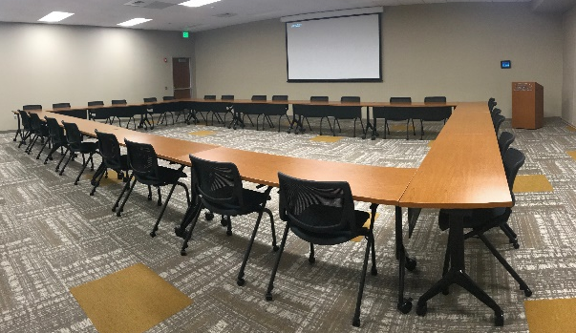
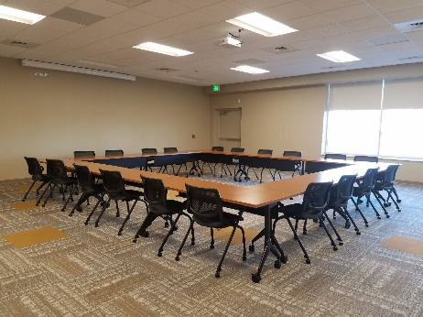

Lake Room – Square for 28
Dune Room – Square for 24

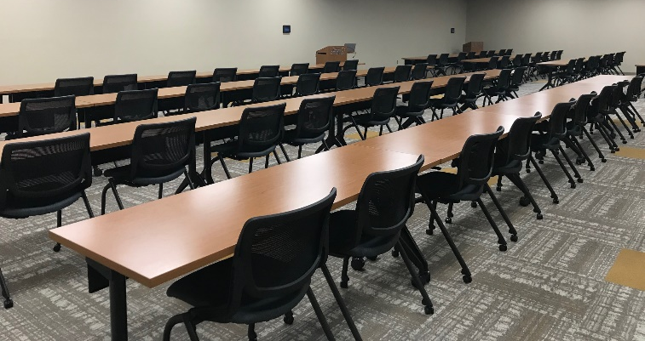
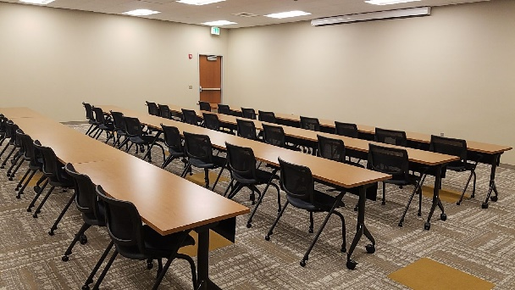

Lake Room – Classroom for 40
Lake/Harvest Rooms – Classroom for 72

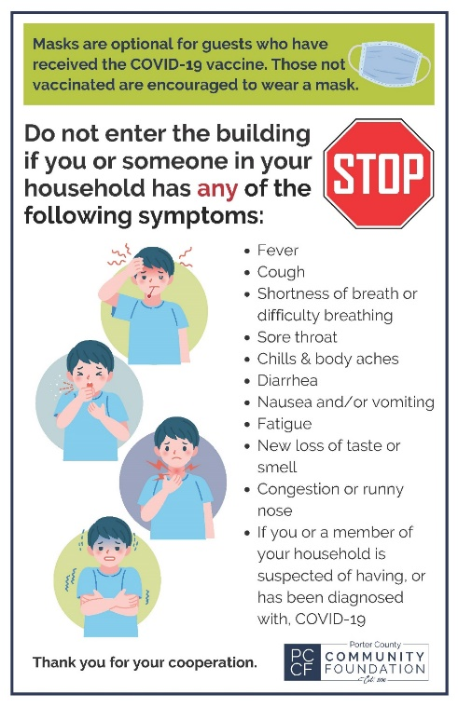
- COVID-19. Rooms are cleaned between each meeting. In addition, the attached rules are posted throughout the Nonprofit Conference Center. Each Attendee should be aware of these rules and be prepared to comply prior to entering the Building.

Nonprofit Conference Center
Center for Community Philanthropy

Request Form

Please complete this form and email along with any additional information to center@pccf.gives. Please note that submission of this request form is NOT confirmation. A written confirmation will be emailed to you within 48 hours after your request has been received.

Double click boxes to add check marks.

Organization Information
Organization:
Address:
City: |  |  |  |  |  |  |  |  | State: |  |  |  |  |  |  | Zip:
Phone: |  |  |  |  |  |  |  |  | Website:
Are you a nonprofit: |  |  |  |  |  |  Yes No
Have you used the Center in the past?
 Yes If so, last date used: |  |  |  |  |  |  |  |  |  |  |  |  |  |  |  |  |  No
Meeting Primary Contact Name and Title:
Phone Number: |  |  |  |  |  |  |  |  |  |  | E-mail:
Cell Phone or after hours contact number (required):
Secondary Contact Name and Title:
Phone Number: |  |  |  |  |  |  |  |  |  |  | E-mail:
Cell Phone or after hours contact number (required):

INSURANCE DOCUMENTATION
Insurance Company:
 Insurance certificate attached naming Porter County Community Foundation as “Additional Insured” and “Loss Payee” per Item 2 in the Guidelines.
 No insurance is maintained as this is an “All-Volunteer” Organization.

Meeting information
Name of Meeting:
Please make sure this is the name of the meeting that your guests will be asking for.
Purpose of Meeting:
Day, Date of Meeting:
Please list actual dates only i.e. do not
put 2nd Tuesday of each month.
Beginning Set Up Time: |  |  |  |  | Start Time: |  |  | End Time:
Number of Attendees Expected: |  |  |  |  |  | Is the Meeting Open to the Public/Membership Distribution List? |  |  |  Yes  No
There are 50 parking spaces available on the property. Please indicate if you need to discuss overflow parking options.  Yes we will need additional space.  No 50 spaces will be sufficient.

ROOM SELECTION AND SETUP
Dune Room (32 Seats Classroom; 44 Seats Theatre; 24 Seats Square)
Room Setup Equipment Needs
Classroom for ___ Seats  Easel for flip chart
Square for ___ Seats  Use of kitchen
Theatre for ___ Seats
Other ____________________________

Harvest Room (32 Seats Classroom; 44 Seats Theatre; 24 Seats Square)
Room Setup Equipment Needs
Classroom for ___ Seats  Easel for flip chart
Square for ___ Seats  Use of kitchen
Theatre for ___ Seats
Other ____________________________
Lake Room (40 Seats Classroom; 52 Seats Theatre; 28 Seats Square)
Room Setup Equipment Needs
Classroom for ___ Seats  Easel for flip chart
Square for ___ Seats  Use of kitchen
Theatre for ___ Seats
Other ____________________________

Harvest/Lake Rooms Combined (72 Seats Classroom; 106 Seats Theatre; 44 Seats Square)
Room Setup Equipment Needs
Classroom for ___ Seats  Easel for flip chart
Square for ___ Seats  Use of kitchen
Theatre for ___ Seats
Other ____________________________

catering information
Will the meeting be catered? |  |  Yes |  No
If yes, name of caterer:
Please make sure a contact person from your organization is present to accept food/caterer delivery. The Foundation will not accept delivery of any items.

The undersigned has read and understands the guidelines, communicated the same to all of its attendees and agrees to conform all activities and conduct while on the premises to the guideline requirements. It is understood that infectious diseases, such as COVID-19, MRSA, Influenza and the like, carry inherent risk of transmission from person-to-person. The Organization is aware of this risk of transmission of infectious diseases at the time of this Application and upon use of the Nonprofit Conference Center. With full knowledge of the foregoing, the Organization, on behalf of itself, its attendees or other related third parties, hereby releases, waives, and discharges the Porter County Community Foundation, its Board of Directors, Officers, employees, independent contractors and agents (collectively “Released Parties”) from any and all liabilities, claims, demands, actions, and causes of action, whatsoever, directly or indirectly arising out of or in any way related to the Organization’s and attendees’ use of the Nonprofit Conference Center (collectively “Released Claims”) arising out of or related to any loss, damage, injury or death, that may be sustained by the Organization or any attendee related to COVID-19 or any other infectious disease to which any Attendee or associated person may have been exposed to as a result of the Organization’s use of the Nonprofit Conference Center. The Organization agrees to indemnify, defend and hold harmless the Released Parties from and against any and all costs, expenses, damages, lawsuits, and/or liabilities or claims, including without limitation attorney’s fees and litigation expenses, incurred by any of such Released Parties as a result of any claims or suits made by the Organization, any attendee or third party against any of the Released Parties to recover any losses, liabilities, costs, damages or expenses due to the Released Claims.

________________________________________ _____________________
Signature and Title Date

